**Venora Hotel Reservation Analysis**

This project involves the creation of an interactive Excel dashboard designed to analyze hotel booking data. The dashboard allows users to explore key metrics, such as booking rates, cancellation rates, and revenue trends. It also provides insights into customer preferences and behavior, enabling hotel management to make informed decisions based on data-driven insights.

**Key Features**

* **KPI Cards:** Provided to measure the performance of the business, Will give the overview of total booking count, cancellation %,Total Revenue, Total Number of the room booked for night stay, Average room rate.
* **Booking Trends**: A clear view of booking patterns over time, helping to track peak booking periods.
* **Customer Preferences**: Analysis of category of customer who has invested, booking chancel pattern they used most
* **Cancellation Analysis**: A section dedicated to exploring booking cancellations, including key reasons and patterns.

**Data Sources:**

[https://docs.google.com/spreadsheets/d/1yND41g-WWgKOzSfJLvCpDjTRXBtyTF7I/edit?gid=537427480#gid=537427480](https://docs.google.com/spreadsheets/d/1yND41g-WWgKOzSfJLvCpDjTRXBtyTF7I/edit?gid=537427480%23gid=537427480)

**Sample Screenshot:**

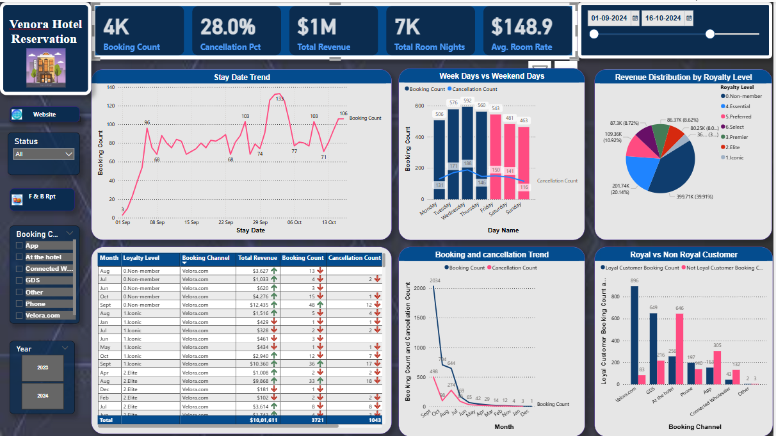

**Visualizations used in the dashboards:**

**KPI Cards:** These metrics are provided to evaluate business performance, offering an overview of the total booking count, cancellation percentage, total revenue, total number of rooms booked for overnight stays, and the average room rate.

**Slicer For Date range selection:** User can slide through the slicer and can select the required date range.

**Slicer card for Year (Button):** Allow the user to select the year**.**

**Filter Card:** This will allow the user to select the booking channel, which allows us to know customer preference media for booking the hotel.

**Text Box:** Website of the hotel is linked to it for easy access.

**Line Chart:** This chart will give the book count over the stay date. From this chart we can easily know the season in which the highest and lowest bookings are taken place. Also, tooltips are given so that when we put cursor on the line you will also get to know the single night room booking count and multi-night room booking count.

One more line chart given to provide the cancellation and booking trend over month

**Line and Stacked columns chart**: Will provide the user with booking counts and cancellation counts over weekend/weekdays. To differentiate between the day’s colors are change also tooltip has provided.

When we place cursors on each bar will get the revenue of each day categorized by loyal level.

**Pie Chart:** will provide the distribution of revenue of each categorized customer.

**Table Chart:** This chart will give you detailed description of total revenue, booking count, cancellation count and average room rate are categorized using different level of customer, booking channel and month. A conditional formatting is applied to total revenue as the revenue is >$500 , increase icon is provided, these are applied to the booking and cancellation count as well.

**Data Cleaning and Transformations:**

1. First row promoted to Headers
2. Created New Calculated column for getting revenue for each row using [Number of nights] * [Room Rate]
3. Renamed the column as Revenue.
4. Created calculated column for “How far away **“** usingDuration.Days([Stay Date] - [Booking Date])

Applied conditional formatting to get the status as each if [#"How far away?"] <= 7 then "1. Before a week" else if [#"How far away?"] <= 14 then "2. Before 2 weeks" else if [#"How far away?"] <= 28 then "3. Before 4 weeks" else "4. More than 4 weeks") , bucket created for the column

1. Extracted day name from booking date using Date.DayOfWeekName([Stay Date])
2. Inserted day of week using Date.DayOfWeek([Stay Date],1))

**Attributes used:**

**Booking ID :** Generated unique ID while reservation successful eg: RES009721, RES009722 etc

**Booking Date:** Date when booking is completed successfully eg: 22-Sep-24, 17-Jul-24 etc

**Booking Channel:** Through which source booking is completed eg: Phone, At the Hotel etc

**Loyalty Level:** Type of the customer eg: Preferred, Essential etc

**Status:** Status of the booking eg: committed, cancelled ect

**Stay Date:** Dates where customer stayed in Hotel eg: : 22-Sep-24, 17-Jul-24 etc

**Number of nights**: No of nights customer booked to stay at Hotel eg; 2,1,3

**Room Rate:** Price of the Room : eg: 189.15,132.85 etc

**Calculations and measures created:**

1. Booking Count = COUNTROWS(bookings)
2. Cancellation Count = CALCULATE([Booking Count], bookings[Status] = "Cancelled")
3. Cancellation Pct = DIVIDE([Cancellation Count], [Booking Count])
4. Total Revenue = SUM(bookings[Revenue])
5. Avg. Room Rate = DIVIDE([Total Revenue], [Total Room Nights])
6. Loyal Customer Booking Count = CALCULATE([Booking Count], bookings[Loyalty Level]<>"0.Non-member")
7. Not Loyal Customer Booking Count = CALCULATE([Booking Count], bookings[Loyalty Level]="0.Non-member")
8. Multi-night booking count = CALCULATE([Booking Count], bookings[Number of nights]>1)
9. Single night booking count = CALCULATE([Booking Count], bookings[Number of nights]=1)
10. Total Room Nights = SUM(bookings[Number of nights])

**Conclusion**

This Excel dashboard helps hotel management by providing key insights into booking behaviour, revenue trends, and cancellations. The interactive nature of the dashboard enables dynamic analysis of different business scenarios, empowering decision-makers to optimize booking strategies.